Document to update struts project while convert into Maven
(dependency should automatically update)
Prepare By : Garun Mishra
Date : 2017-02-15

A. Process to update Struts project while convert it into maven :

1. ect war file in eclipse/sts:
(File->import->war->select the war project)
2. Convert the project into maven.
(Select project->configure->convert to maven project)
fill the details and click on finish.
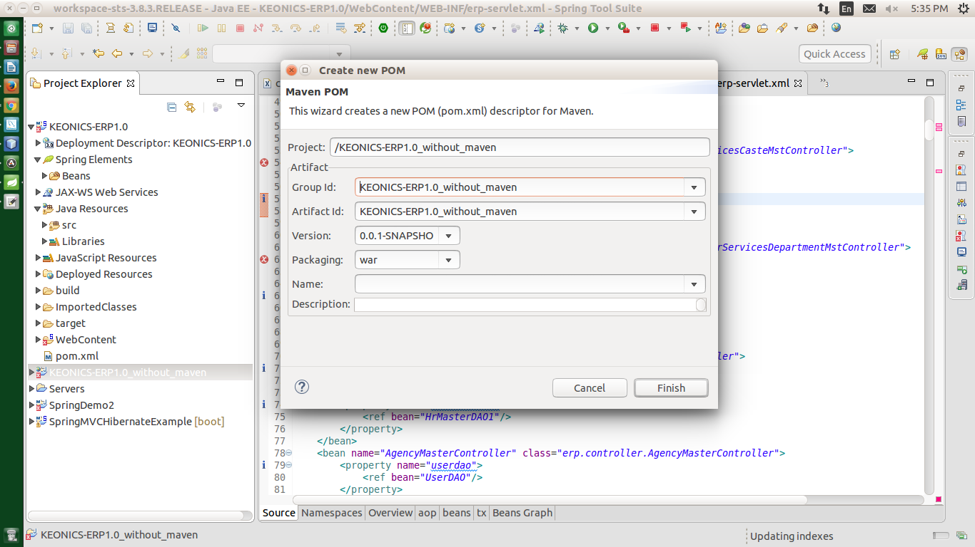

3. Add the appropriate dependencies as per your project requirements.
4. after convert the project, the structure of project will be change.
5. Now you have to check for appropriate redirection of your project flow and their configuration.

B. Update the POM dependencies :

1. right click on your project->mave->update project.
2. check the force update of Snapshot/Release.

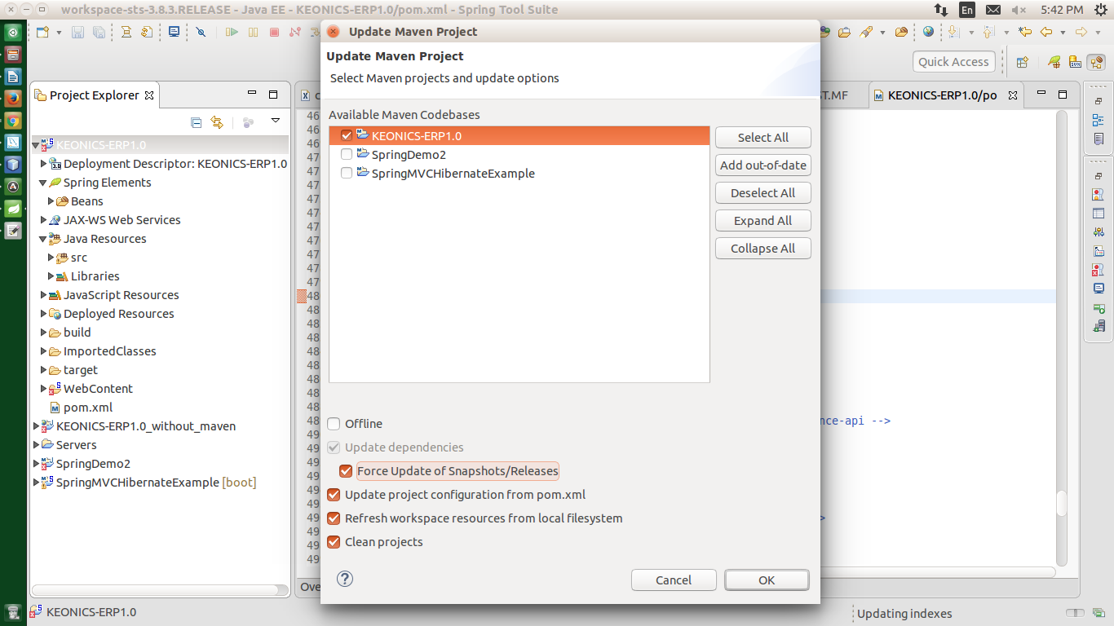

3. It will take little bit time to update your project's pom dependencies.
4. Now your project is fully maven based.

